Course: High Performance Computing Lab

Practical No 1

PRN: 22510033
Name: Jasmine Imtiyaj Sayyad
Batch: B8

Title: Introduction to OpenMP

Problem Statement 1 – Demonstrate Installation and Running of OpenMP code in C
Recommended Linux based System:
Following steps are for windows:
OpenMP – Open Multi-Processing is an API that supports multi-platform shared-memory multiprocessing programming in C, C++ and Fortran on multiple OS. OpenMP uses a portable, scalable model that gives programmers a simple and flexible interface for developing parallel applications for platforms ranging from the standard desktop computer to the supercomputer.

To set up OpenMP,
We need to first install C, C++ compiler if not already done. This is possible through the MinGW Installer.
Reference: Article on GCC and G++ installer (Link)
Note: Also install `mingw32-pthreads-w32` package.

Then, to run a program in OpenMP, we have to pass a flag `-fopenmp`.
Example:
To run a basic Hello World,
#include <stdio.h>
#include <omp.h>

int main(void)
{
#pragma omp parallel
printf("Hello, world.\n");
return 0;
}

gcc -fopenmp test.c -o hello
.\hello.exe
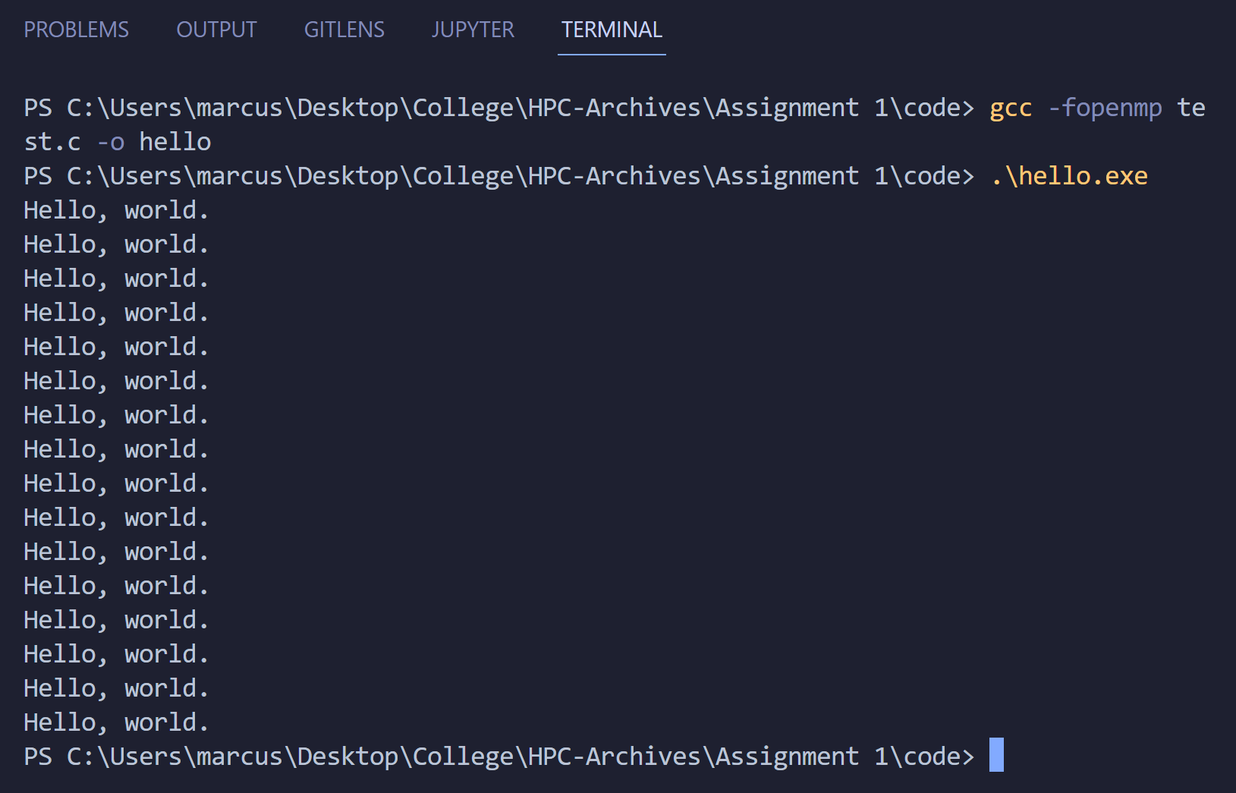

My code and Output:
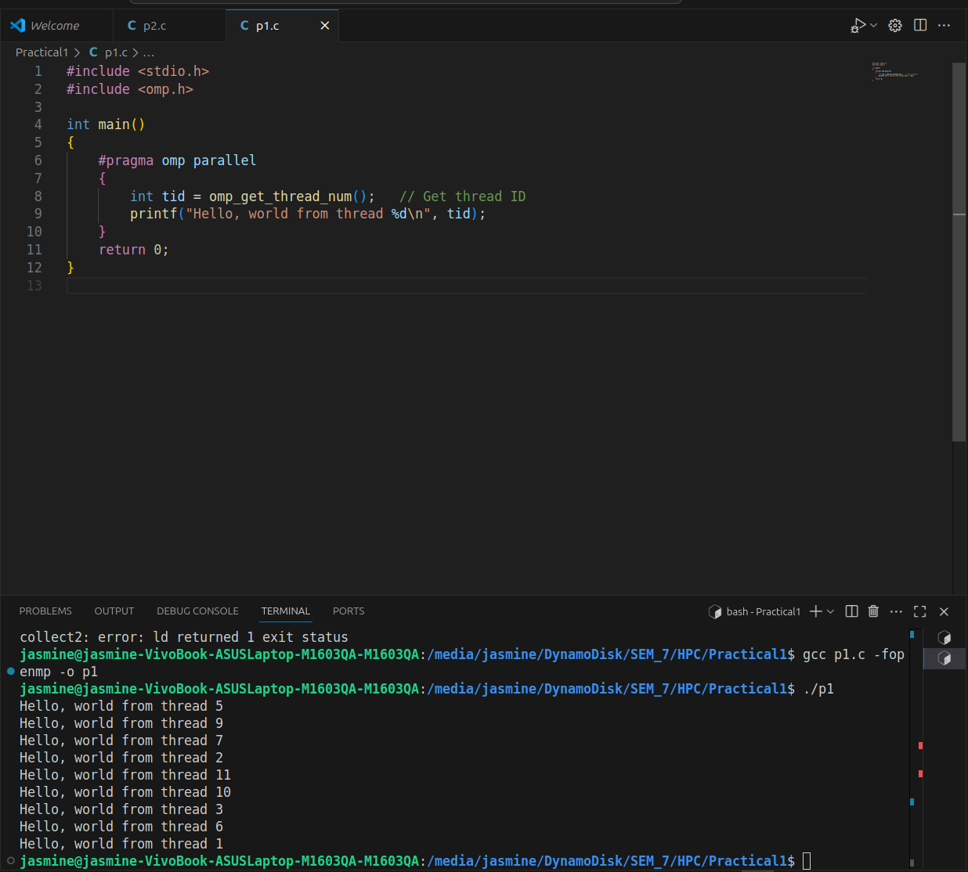

Problem Statement 2 – Print ‘Hello, World’ in Sequential and Parallel in OpenMP
We first ask the user for number of threads – OpenMP allows to set the threads at runtime. Then, we print the Hello, World in sequential – number of times of threads count and then run the code in parallel in each thread.

Code snapshot:
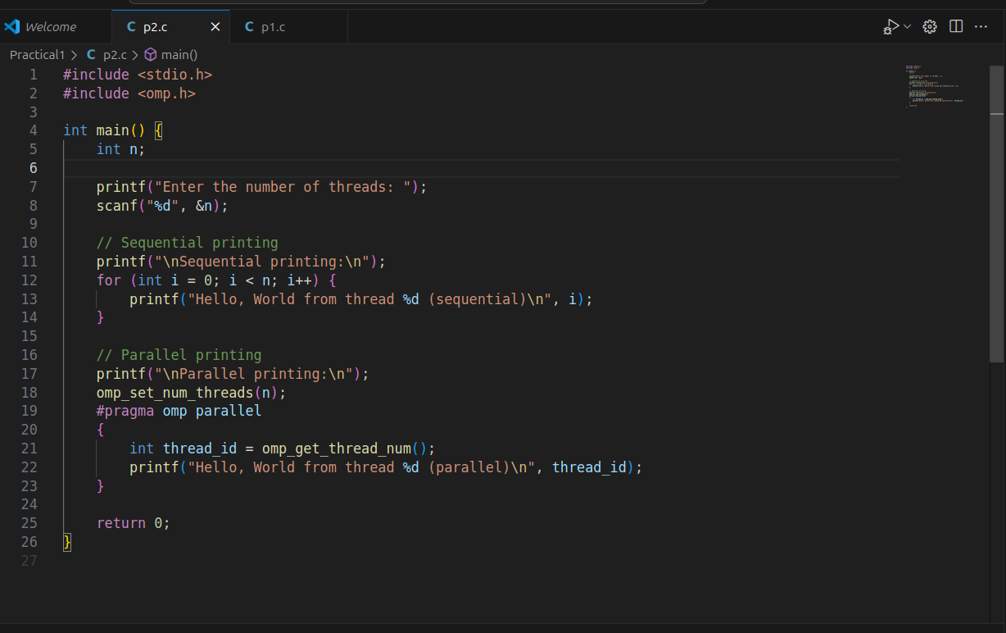
Output snapshot:
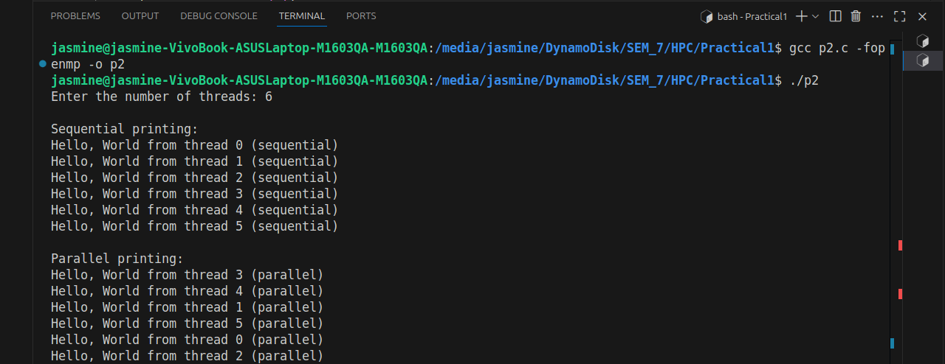
Analysis:
User enters the number of threads n.
Sequential section: Prints n lines in order using a single thread (main thread).
Parallel section: Spawns n threads using OpenMP. Each thread prints its ID. Output order is not guaranteed because threads run concurrently.
Time complexity: O(n) (work is split across threads in parallel section).
Key concept: Demonstrates the difference between sequential execution and parallel execution using OpenMP.

GitHub Link: make a public repository upload code of an assignment and paste its link here.
https://github.com/jasminesayyad29/HPC
Problem statement 3: Calculate theoretical FLOPS of your system on which you are running the above codes.
Elaborate the parameters and show calculation.
AMD Ryzen 5 5600 CPU
FLOPS=Cores×Clock Speed×FLOPs per cycle (per core)

Single Precision (FP32)

FLOPS=6 cores×4.4 GHz×16 = 422 Gflops

Double Precision (FP64)

FLOPS=6 cores×4.4 GHz×8 = 211 Gflops
CPU can perform more single-precision operations than double-precision because:
Single precision requires fewer bits, so the processor can pack and process more of them in one instruction

